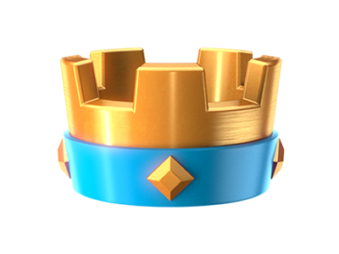

Adam Wilkie

Contents

Requirements 4

Concept and Design 5

Database 7

UI Work 11

Web Scraping 15

Accessibility 19

PWA 24

Directory Structure 27

References 32

# Requirements

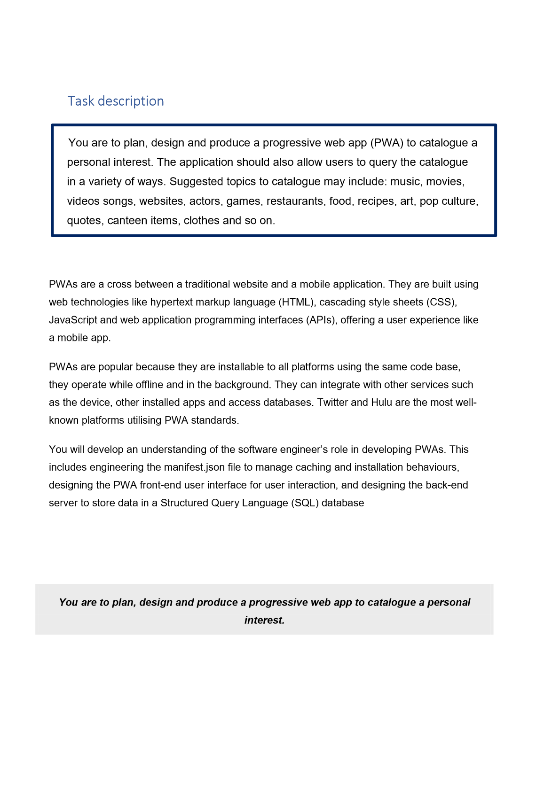

# Concept and Design

Starting this out I needed an idea. Many came to me, such as a guitar database, a song database, etc. But I felt what really called to me was Clash Royale. I have played the game for years and know the mechanics of it through and though, so I felt it made the most sense to do to feel the most comfort and enjoyment while doing it.

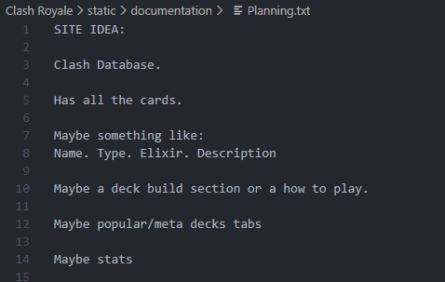

This here was the very first addition to my project. My plan.

As you can see, I planned to show all the cards, and details about each card with an additional deck builder and stats of cards. Upon continuing and completing this project I had completed what I had first set upon myself, being a display of all the cards and their stats.

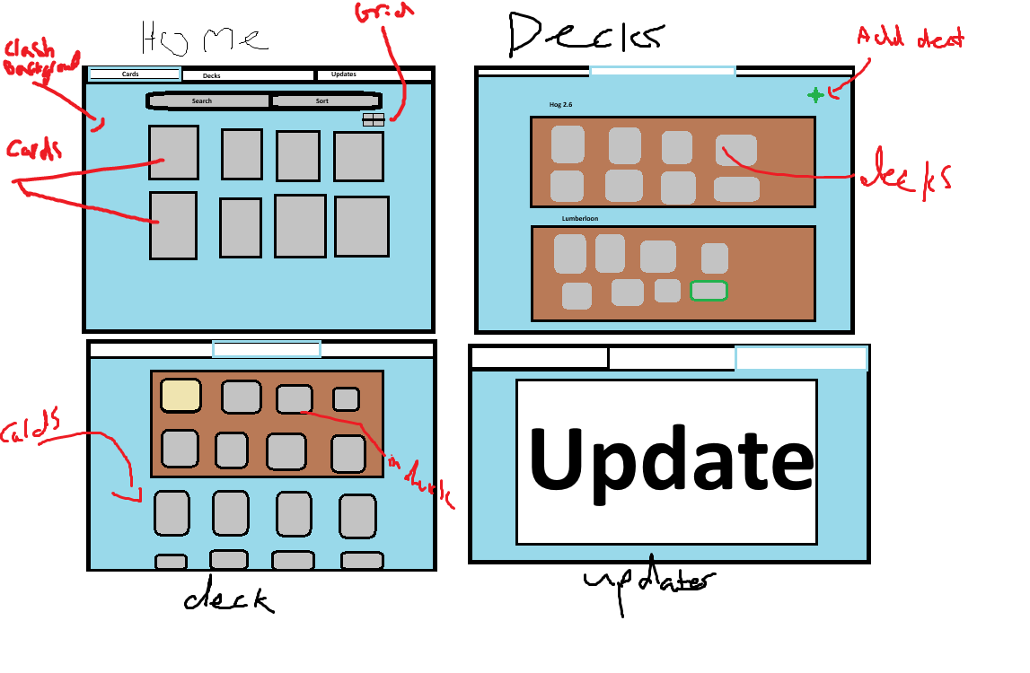

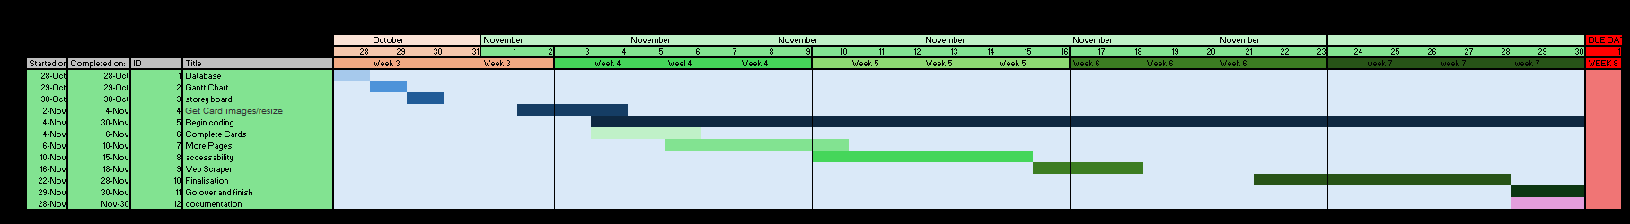

This is a story board and gannt chart of my original concept fort his page. As you can see on the first page, it is showing a look of all the cards. This reaches back to what I had mentioned before with the display of them and their stats, Next 2 pages shows the idea of a deck page and adding cards to the decks. Next was an update page showing the update logs of the game.

# Database

I made my Database in a JSON file. Which shortly later I found I shouldn’t be doing and have straight into a SQL file.

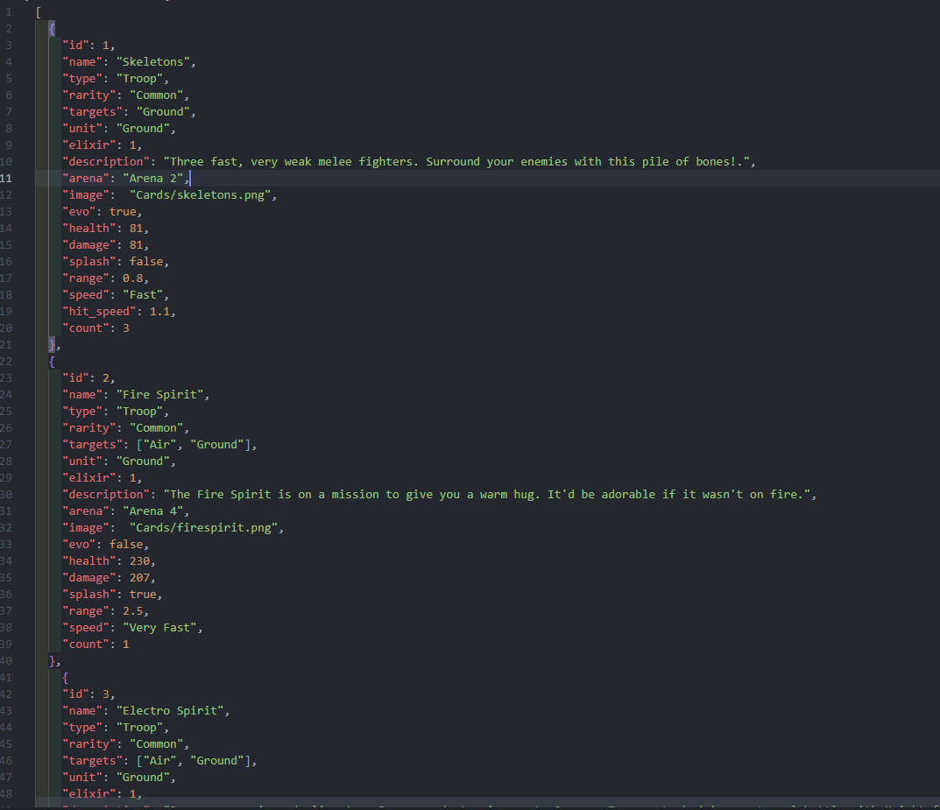

This here is how I did my JSON file, Which I converted into a database like this:

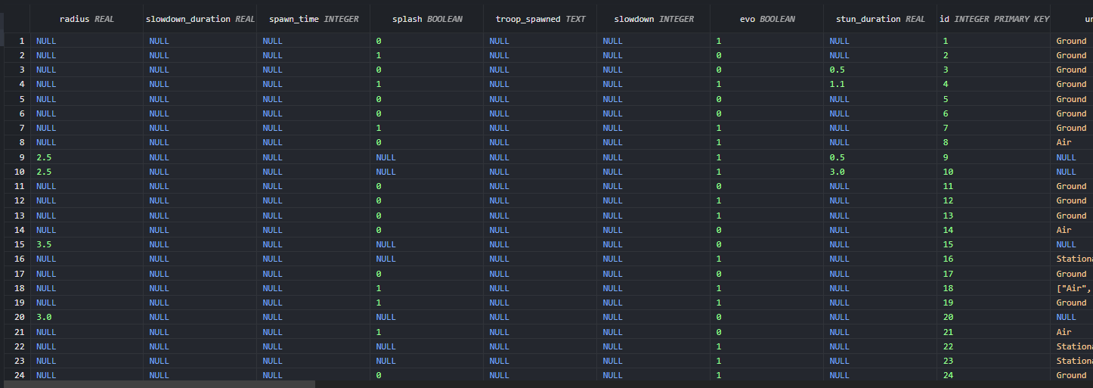

With a AI Generated python file. This saved me manually converting it all.

All my data for the cards, such as health and damage came from a site called deck shop pro,

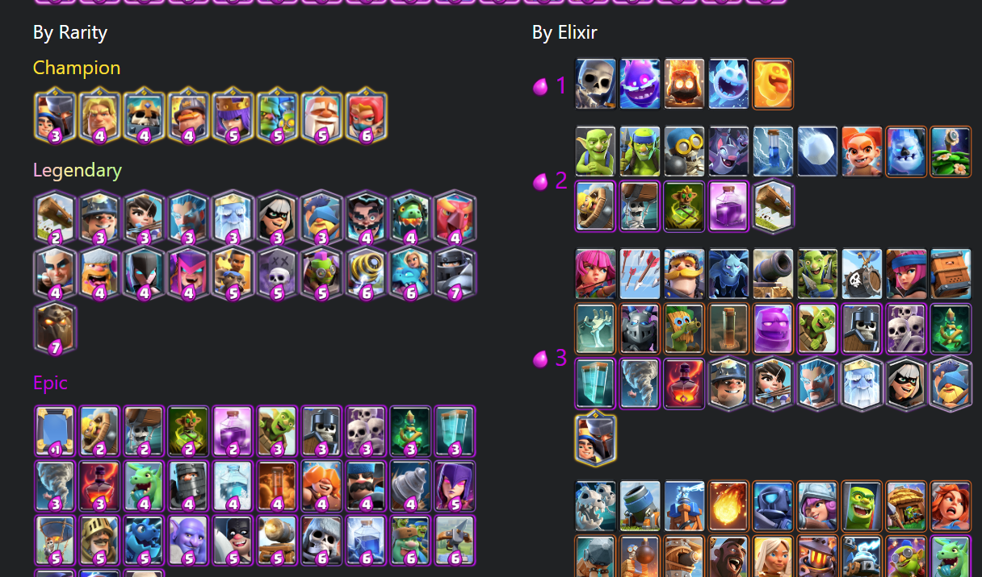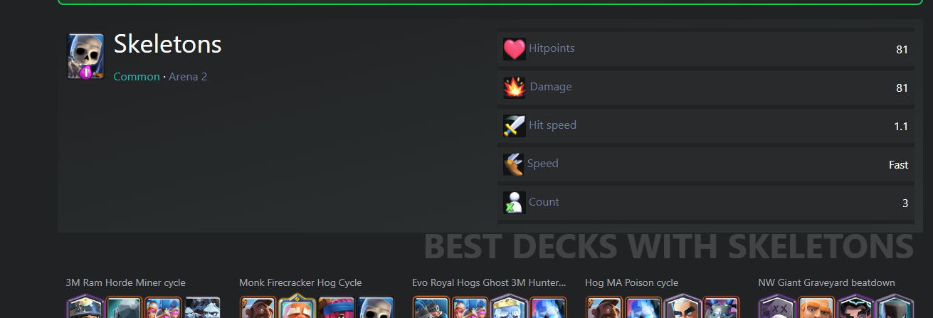

This provided me will all the data I needed for this database, but the next issue I had was card images.

I got all my card images from a site called Supercell Fankit

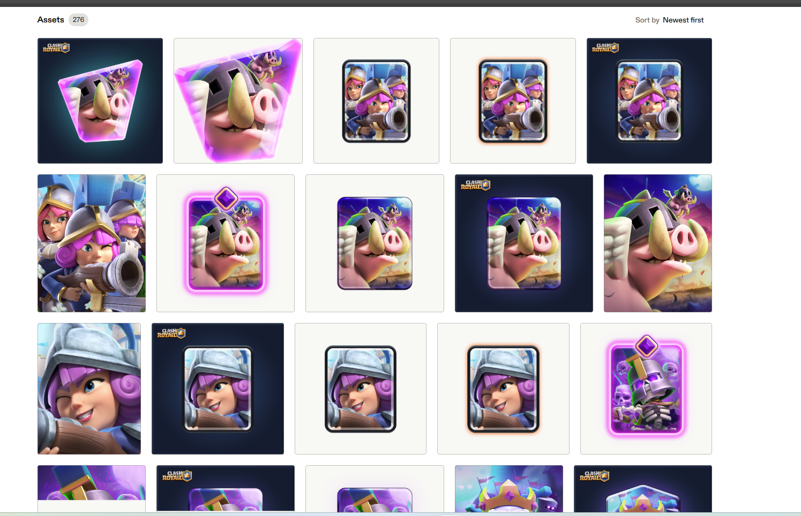

Which I went through and selected every card image I wanted, which allowed me to download all of them and add them to a card images file.

The way I managed to call from my database to use the features was as following:

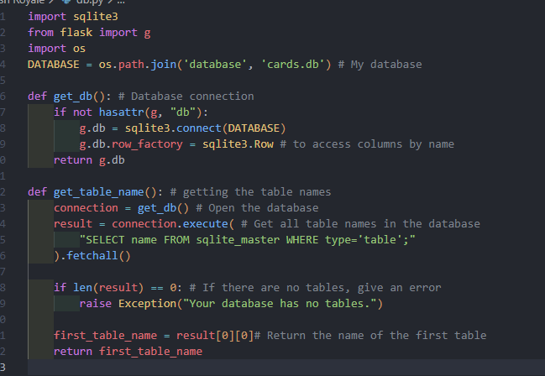

This code here searches for tables within my database, which I have one of, then access all the data within.

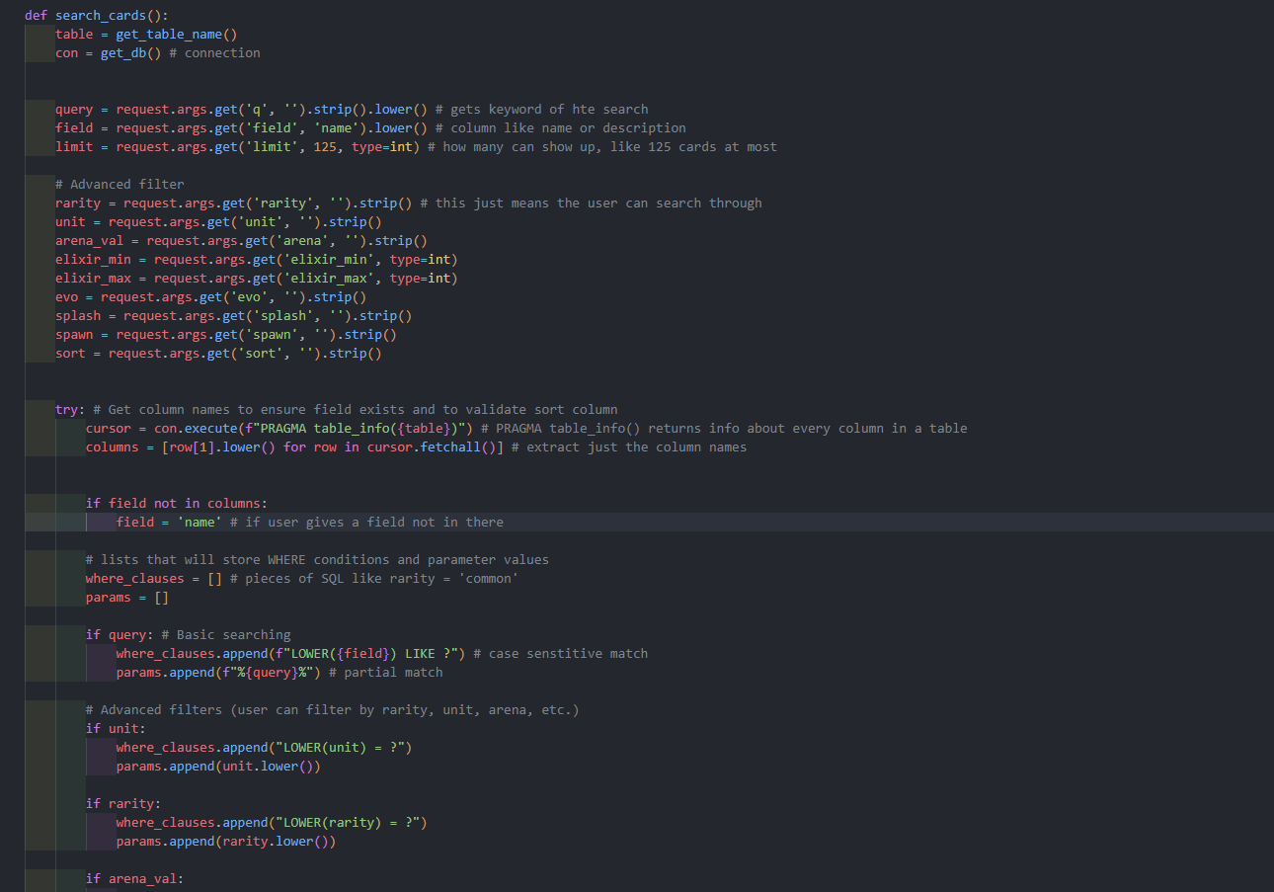

(More code like this follows in order to fulfill other needs)

This is how I managed my sorting, it gets the data from the database and fills the column names with what the user asks of the search bar

# Web Design

1. Planning & Setup  
I began by planning the layout of my website and deciding on the main pages I needed: Home, Cards, Blogs, Contact, etc.  
I also set up a Flask project structure with folders for templates, static files, images, styles, scripts, and a database.

2. Creating the Database, Searching System, and Cards Page  
The first major feature I built was the database system.  
I set up SQLite tables and created the logic needed to fetch data through Flask.

Cards Page:  
• I connected it to the SQLite database.  
• I created a Python route to fetch card data.  
• I displayed card images based on the database.  
• I styled the page using cards.css.

I also built the search functionality early on, so users could look up cards smoothly.

3. Creating the Blogs Page  
Next, I worked on the Blogs page.  
• I wrote a scraper in Python using requests and BeautifulSoup.  
• I stored the collected blog data and rendered it with Flask templates.  
• I styled the page using blogs.css.

4. Building the Navigation System  
After my dynamic pages were working, I created the navigation bar.  
I made it a reusable HTML component called nav.html so it could be included on every page.  
I styled the navigation using navigation.css  
This gave my site consistent structure and allowed me to move between pages easily during development.

5. Creating the Home Page  
Once the navigation and data pages were complete, I started building the Home page.  
This page became the main UI, like a game interface.

I added several components in order:

1. The XP section
2. The Gold counter
3. The Gems counter
4. The Settings panel
5. The arena image
6. The Battle button
7. Background music and the audio player

I connected this page to multiple CSS files like styles.css, home.css, and navigation.css to control layout, colours, and animations.

6. Adding JavaScript Interactions  
After the visual layout was working, I added JavaScript to make the site interactive.

• script.js controls button behaviour and animations.  
• accessibility.js enables a toggle for Accessibility Mode.  
• app.js is used for PWA features, including the service worker and offline caching.

This stage made the site feel more like an app instead of a static website.

7. Setting Up the PWA (Progressive Web App) Features  
Once the site was functional, I turned it into a Progressive Web App.

I added:  
• manifest.json  
• a service worker in app.js  
• a theme color  
• the ability to install the site on mobile or desktop

This allows the page to work offline and behave like a real application.

8. Adding Extra Pages (Contact, About, etc.)  
With the main parts finished, I built supporting pages:  
• Contact Page  
• About Page  
• Any future pages the site needs

These pages reused the navigation bar and global styles for consistency.

9. Final Polish & Debugging  
In the final stage, I fixed pathing issues, cleaned up my routes, optimized image sizes, and tested everything on mobile.  
I also combined duplicate scripts, removed unused elements, and ensured the PWA installed correctly.

Summary

To summarise, my workflow was:

1. Project setup
2. Database + Cards page
3. Blog scraper + Blogs page
4. Navigation system
5. Home page layout
6. JavaScript interactions
7. PWA installation
8. Extra pages
9. Final debugging and polish

Each stage built on the previous one, and by the end, the site functioned as a complete PWA with interactive elements, dynamic content, and a consistent design.

# UI Work

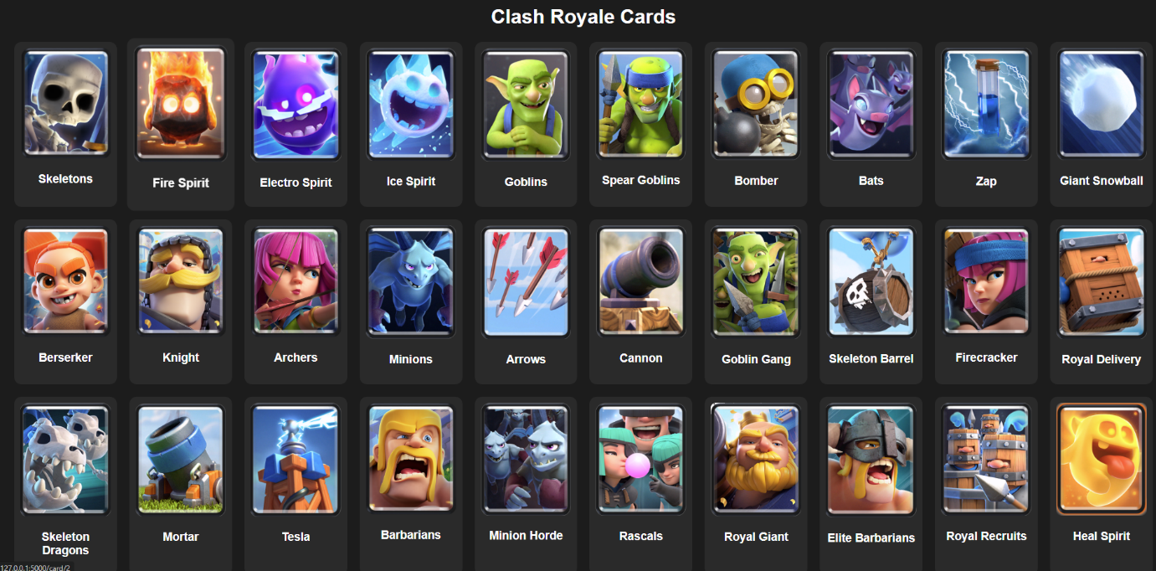

This here was my original design after completing the database. It’s a very simple design, purely just uneven card images with text of the cards name

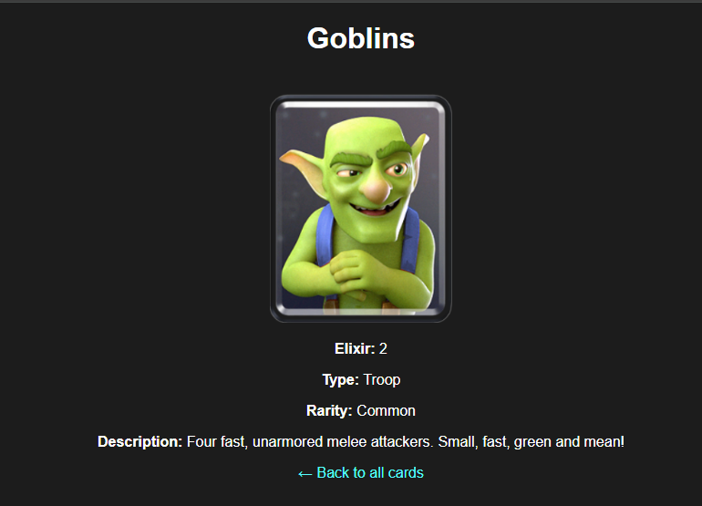

Clicking on the cards displayed this simple look, showing the very basics of the cards.

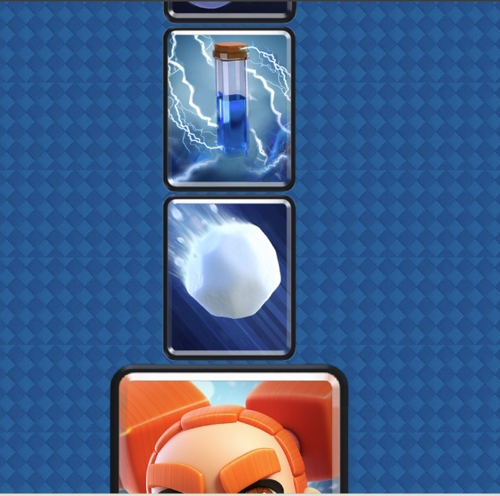I focused on fixing the displayal of card stats before I did the main page, this was the the result of doing that:

As you can see, This ruined the look of the main pag, ruining the grid layout,

But this was the card stats image



This was greatly improved, and was left as almost final with only a few changes left that were needed, this allowed me to be able to

I then stopped working on UI and worked on functionaility

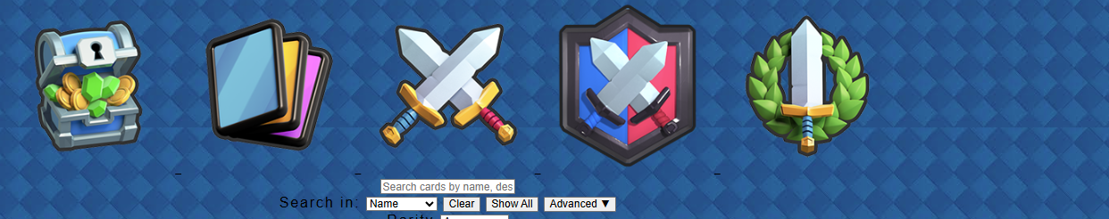

Despite not looking good, I had added a navigation buttons, searching and a main page.

The next step was UI.

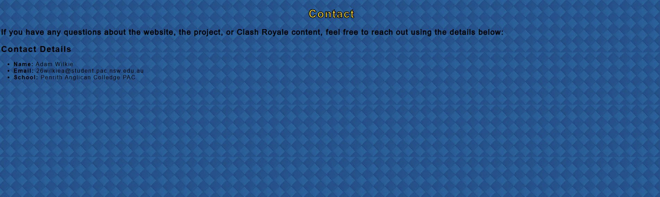

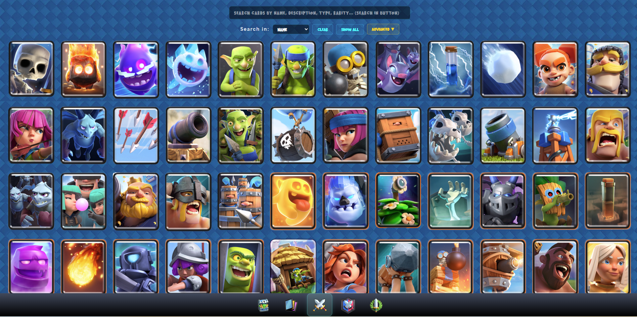

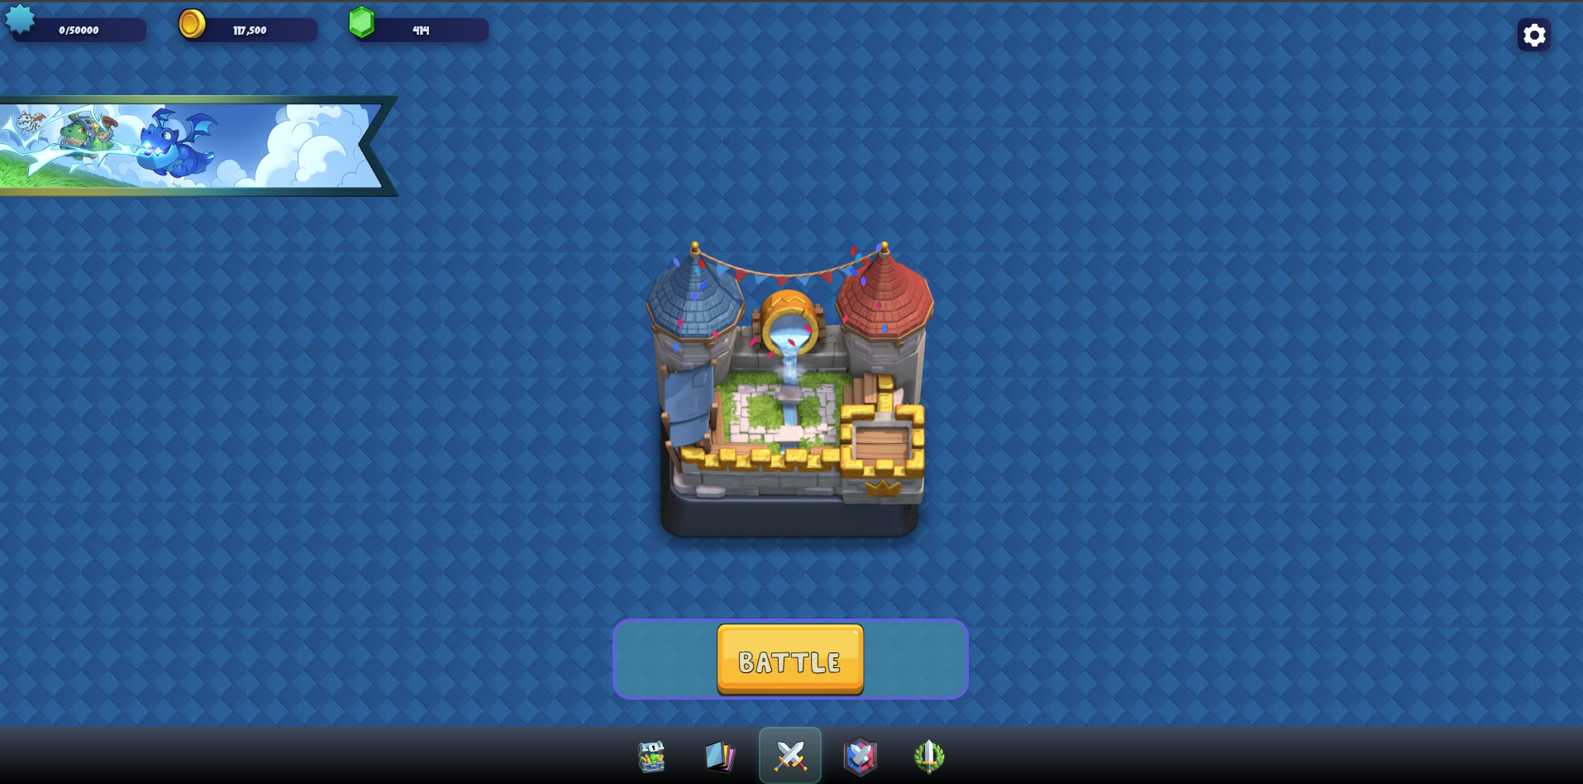

As you can see, I have done MASS UI works, I have styled my home page in a way to that looks like the source material, my cards page has searching with better UI, and my other 2 pages are as simple as I need them to be. I just had to find something to do with my last page . . .

# Web Scraping

I remembered back to my original story board and wondered how I could make the update logs.

I first thought of using the Royale API that clash royale provides for free, but I shortly realised that’s not how they do their update logs.

Next, I decided Web Scraping, which ended up working exactly as I needed it to.

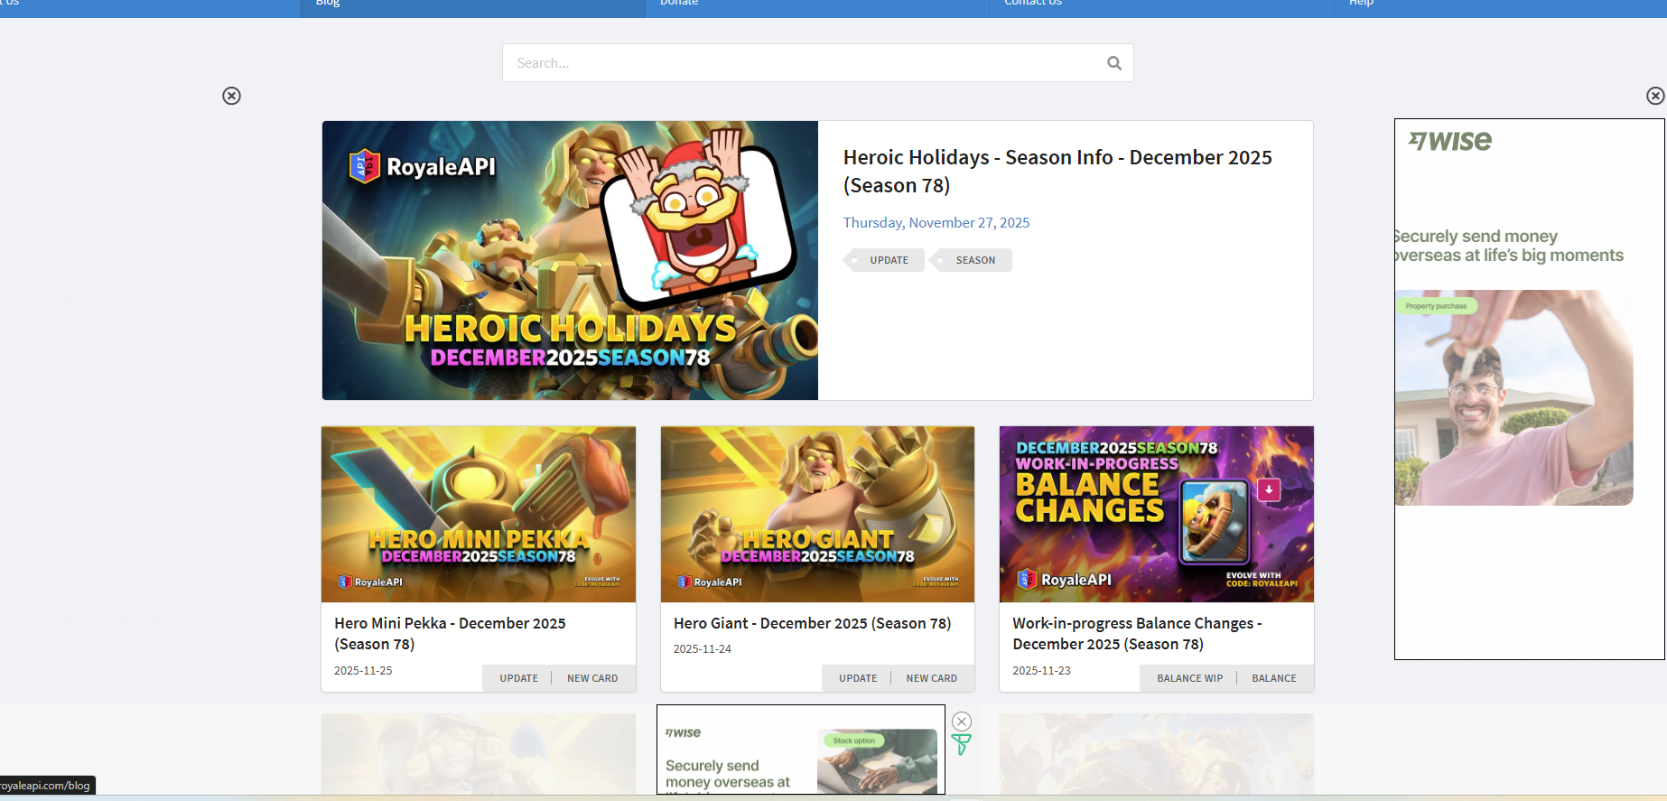

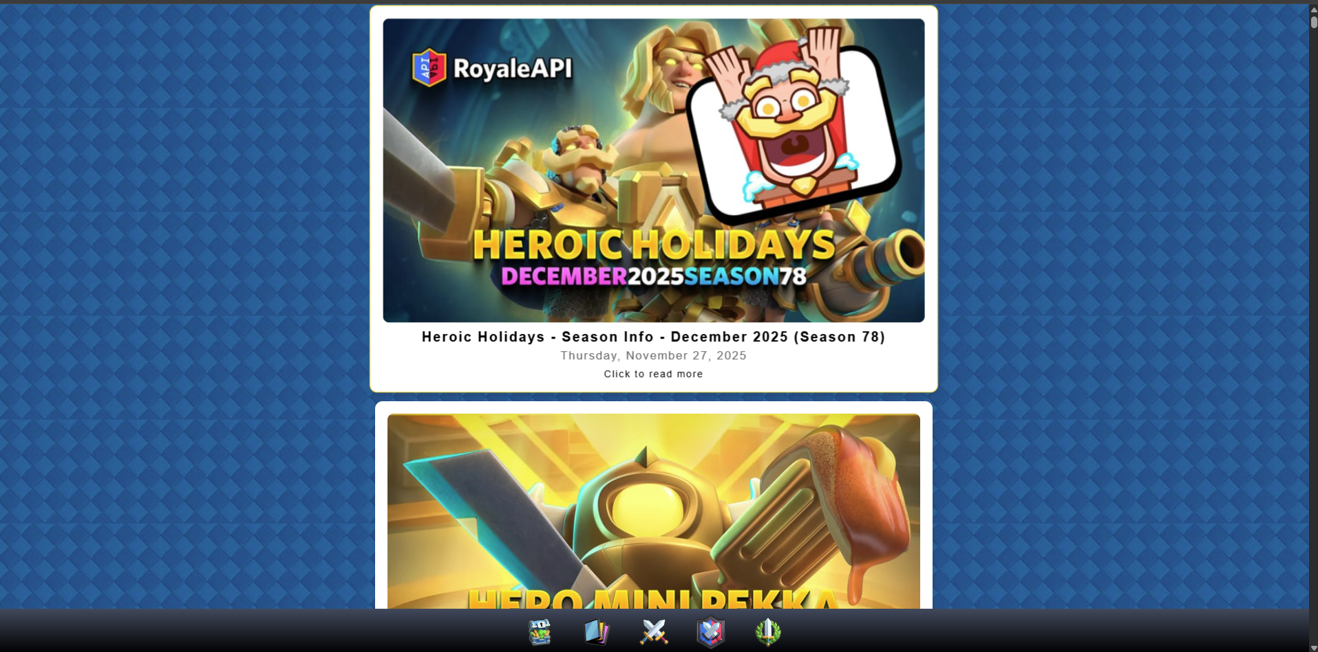

This here is the original site compared to my site that’s scraping it.

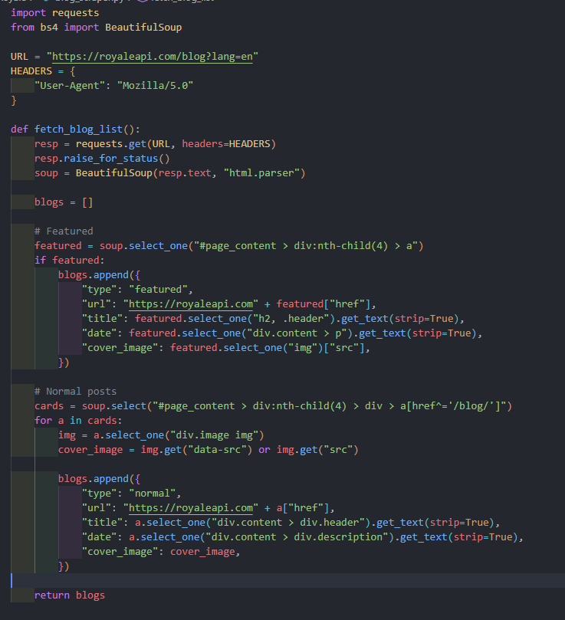

I Had used the Beautiful Soup library to do this.

URL is the site I’m scraping from, and the header is what royale API will see as my user

What the scraper does is it goes to the site, Inspect to elements page,

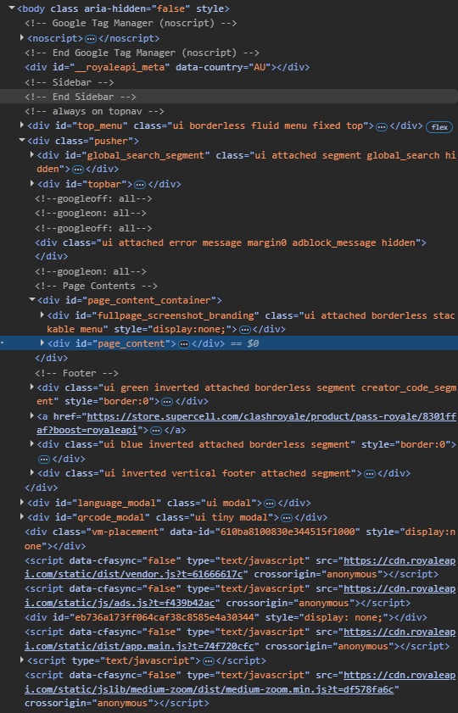

Go through this and find where the blogs are called from and pull that information into my site.

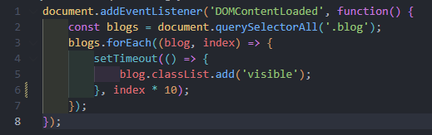

This here part of JS manages how the site loads the blogs/update logs

# Accessibility

Accessibility can be stretched to be various of things, the way I looked at it is text to speech. I had hopes of adding music to the page and felt another form of accessibility could be the control of the sound.

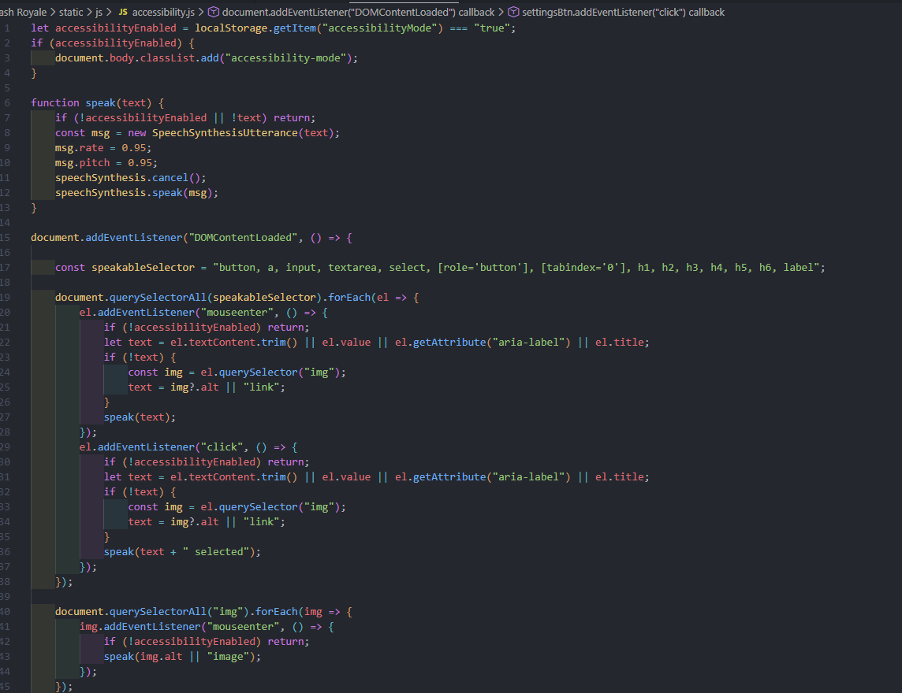

This here is how I’ve managed to do my accessibility.

What it does is when the settings button in the top corner of the main page is pressed, it opens up options



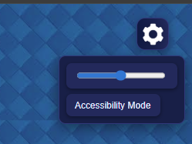

Which grants an accessibility button which will turn on text to speech.

Back to the music. 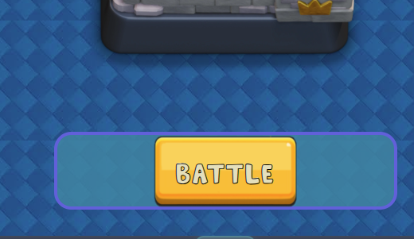

Clicking this button will begin playing the music which the audio of is controlled by the volume slider in the settings.

Which is done like this:

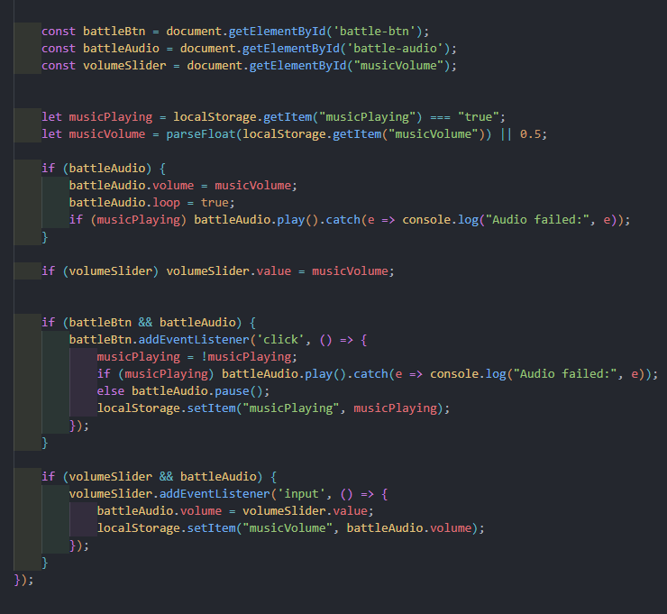

To ensure it is accessible as possible, I have the settings save across multiple pages to ensure that users who need this accessibility don’t have to worry about turning it on again.

# PWA

“”

PWAs are a cross between a traditional website and a mobile application. They are built using web technologies like hypertext markup language (HTML), cascading style sheets (CSS), JavaScript and web application programming interfaces (APIs), offering a user experience like a mobile app.

PWAs are popular because they are installable to all platforms using the same code base, they operate while offline and in the background. They can integrate with other services such as the device, other installed apps and access databases. Twitter and Hulu are the most well-known platforms utilising PWA standards.

You will develop an understanding of the software engineer's role in developing PWAs. This includes engineering the manifest. Json file to manage caching and installation behaviours, designing the PWA front-end user interface for user interaction, and designing the back-end server to store data in a Structured Query Language (SQL) database.

“”

This is what the task asks of the site. Which I have followed.

Below is my manifest. Json

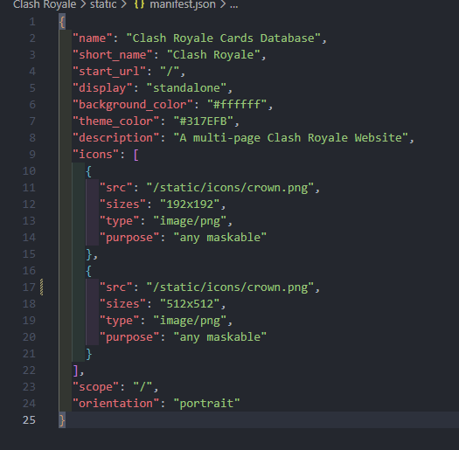

This manages the name of the PWA, descriptions, icons, etc



The following is my service worker

What does a Service worker do?

What This Service Worker Does

Think of this as a smart assistant for your website that makes it work like a mobile app. Here's what it does in simple terms:

1. It Saves Important Files for Offline Use

* When you first visit the website, it saves all the important parts (pages, images, styles) to your device
* This is like downloading the app so it works even without internet

2. It Makes the Website Load Faster

* Instead of downloading everything every time you visit, it uses the saved copies from your device
* This makes the website feel instant, just like opening a regular app

3. It Handles Internet Problems Gracefully

* If your internet connection is slow or goes offline, it still shows you the website using the saved files
* For pages you've visited before, it shows the saved version
* For new pages, it shows a friendly "offline" message instead of an error

4. It Automatically Updates Itself

* When we make improvements to the website, it automatically updates the saved files in the background
* You always get the latest version without having to manually update anything

5. It Makes Installation Possible

* This is what allows the "Add to Home Screen" feature to work
* Your device recognizes this as a proper app that can be installed

In short: This code transforms a regular website into a fast, reliable, installable app that works offline and feels native to your device.

It's like having a personal copy of the website stored on your device that's smart enough to update itself and handle internet problems without bothering you.

This can improve the UX for the Users as it offers the site in a more accessible manner that also loads faster.

# Directory Structure

An important step when making a project is a clean Directory Structure. It is a very important feature, as thus, it has led to me making sure it was as perfect as I could make it.

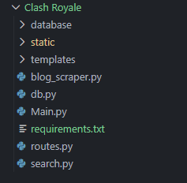

This here is the simplest level of my Directory Structure, Within my templates I hold my HTML files,

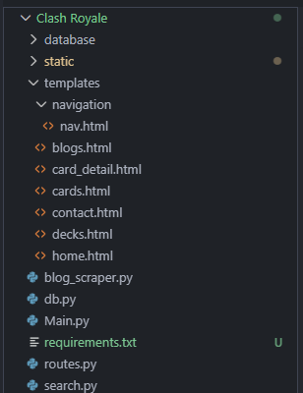

As you can see, This holds files such as home.html, decks.html, contact.html etc. Secondly in my templates folder, I have a folder called navigation with nav.html within it. This is simply how my navigation bar is handles

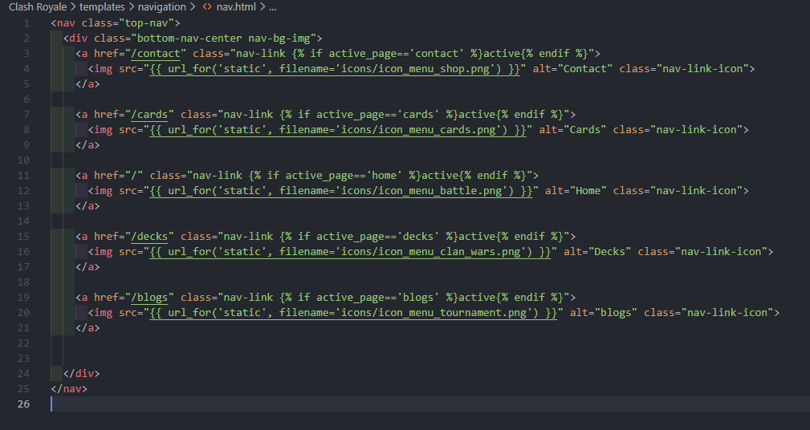

Next is my Static Folder

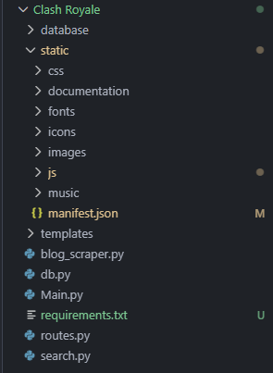

This holds folders such as my documentation, JavaScript, Music, etc.

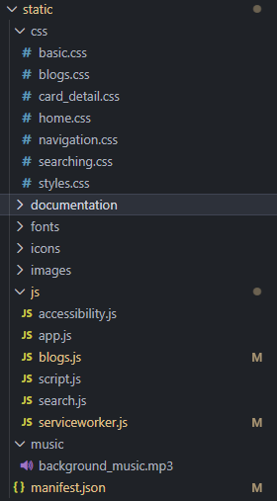

This is where the Styling and functionality of my site are held, My JavaScript’s, Music and styling. Without these my site wouldn’t be Functional, Nor would it look good.

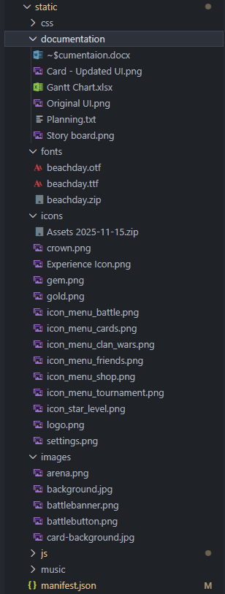

It also holds folders such as images, icons. Fonts and documentation. Images are my backgrounds, battle button, etc. whereas icons are things like gems, coins, navigation buttons. And my fonts and documentation hold the documentation of the whole project and the fonts of the whole site.

The last section in my Directory Structure is my Database

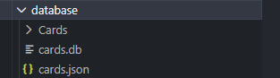

This holds my cards json, My database itself and the card images.

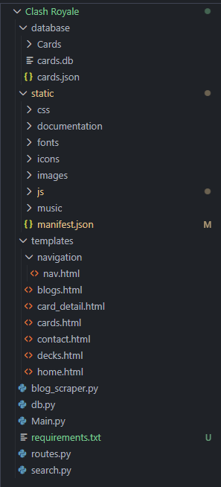

Together they form the Directory of my Project.

# References

<https://www.deckshop.pro/card/list>

Used for card Data

<https://fankit.supercell.com/d/BmehSDJrZNff/game-assets-1>

Used for Card Images

<https://royaleapi.com/blog>

Scraped Site

<https://www.youtube.com/watch?v=SrTn_tq2yNU&t=661s>

for SQL searching

<https://www.youtube.com/watch?v=QhD015WUMxE>

Web Scraping